Project Design Phase-II
Technology Stack (Architecture & Stack)

Date | 30 September 2026
Team ID | SWTID-2026-6276
Project Name | AI StudyBuddy API – Deliver Intelligent, Personalized Study Assistance
Maximum Marks | 4 Marks

Technical Architecture:
The architectural diagram and the information as per Table-1 and Table-2 are given below.
AI StudyBuddy API – Technical Architecture
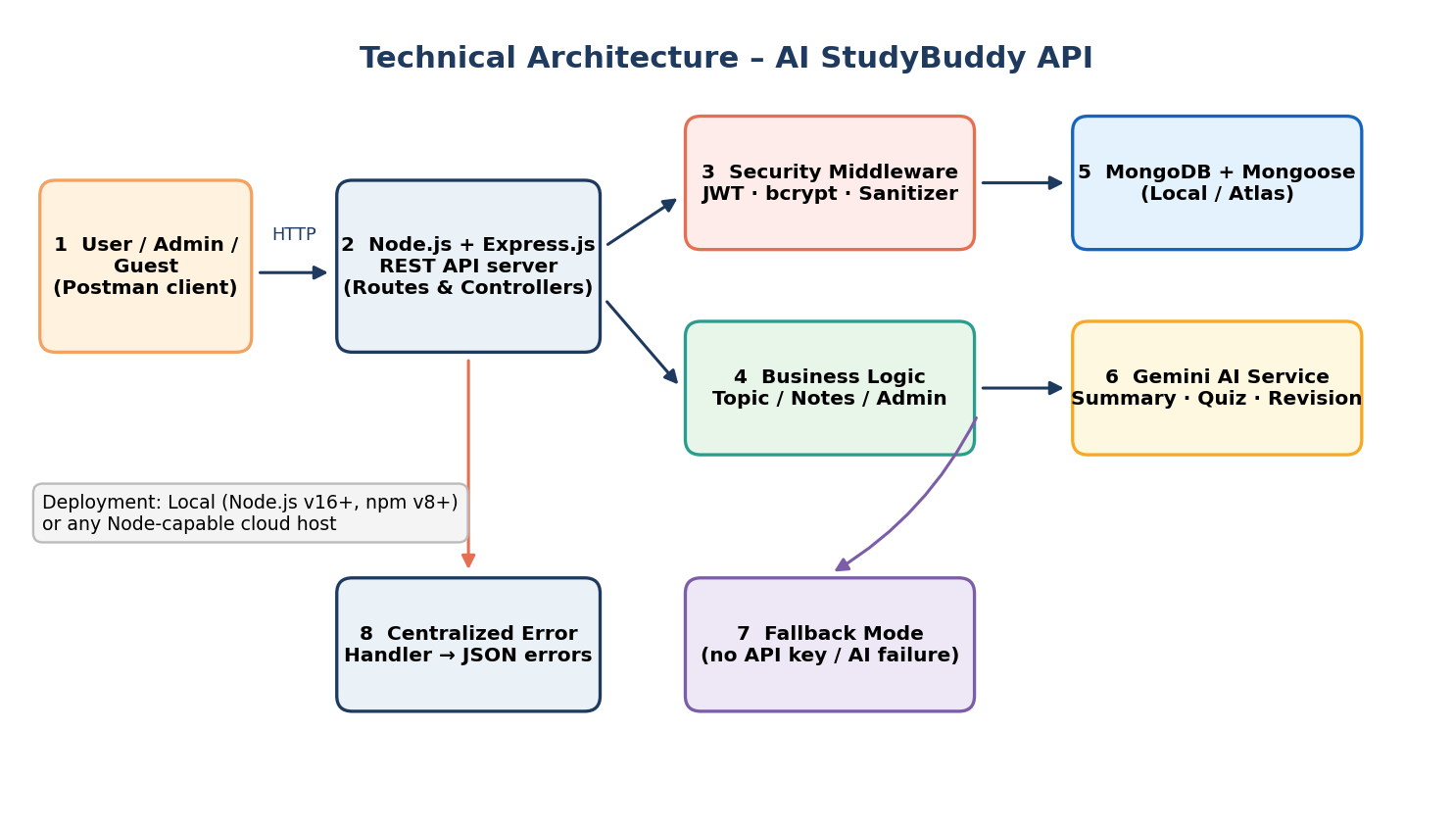

Table-1 : Components & Technologies:
S.No | Component | Description | Technology
 | User Interface | How users interact with the application: REST API consumed through Postman (front-end web/mobile client planned) | Postman (JSON over HTTP); React/mobile client – future
 | Application Logic-1 | Authentication: register, login, JWT issuance and validation, bcrypt password hashing | Node.js, Express.js, jsonwebtoken, bcrypt.js
 | Application Logic-2 | Subject/topic CRUD and study notes & progress management scoped to the authenticated user | Express.js controllers, Mongoose
 | Application Logic-3 | AI study aid module: builds prompts from notes and returns summary, quiz and revision plan (with fallback mode) | Gemini AI service (@google/generative-ai)
 | Database | NoSQL document database with User and Topic collections (one-to-many) | MongoDB with Mongoose ODM
 | Cloud Database | Not used in the current build (local MongoDB); a hosted MongoDB service can be adopted for deployment | Local MongoDB (cloud hosting optional)
 | File Storage | No file uploads; only source code on the local file system | Local file system
 | External API-1 | Google Gemini API used to generate summaries, practice questions and revision recommendations | Google Gemini AI (@google/generative-ai)
 | External API-2 | Not applicable – no second external API is used | —
 | Machine Learning Model | Large language model used for natural-language study aids (consumed as a service, not trained by the team) | Google Gemini (LLM)
 | Infrastructure (Server / Cloud) | Local Server Configuration: Node.js v16+, npm v8+, MongoDB, Intel i5/Ryzen 5, 8–16 GB RAM, 1 GB disk (Windows / macOS / Linux). Cloud Server Configuration: any Node.js-capable host (optional). | Local (VS Code, Nodemon); cloud – optional

Table-2: Application Characteristics:
S.No | Characteristics | Description | Technology
 | Open-Source Frameworks | Open-source runtime, framework and libraries used | Node.js, Express.js, Mongoose, jsonwebtoken, bcrypt.js, Nodemon
 | Security Implementations | JWT authentication, bcrypt password hashing, role-matrix access control, XSS/NoSQL injection sanitization, server-side API keys | JWT, bcrypt, custom sanitization middleware
 | Scalable Architecture | Stateless REST API with modular MVC structure (routes, controllers, middleware, models, services); can scale horizontally | Node.js/Express, MongoDB
 | Availability | Fallback mode and centralized error handling keep the API responding when the AI service or key is unavailable; multiple stateless instances can be run behind a load balancer | Fallback service, error-handling middleware
 | Performance | Asynchronous non-blocking I/O, indexed queries, lightweight JSON payloads; caching of frequent AI responses planned as an enhancement | Node.js event loop, Mongoose indexes

References:
https://c4model.com/
https://nodejs.org/docs
https://expressjs.com
https://mongoosejs.com
https://ai.google.dev

